Dr. D. Y. Patil Pratishthan’s
D. Y. Patil Institute of Master of Computer Applications and Management Sector No.29, Behind Akurdi Railway Station, Pradhikaran, Nigdi, Pune – 411044 (Approved by AICTE, Recognized by DTE, Mah.; Affiliated to SPPU )

Academic Year 2023-24
Subject: Object Oriented Software Engineering MCA I Sem I
Faculty Name: Shalaka Kulkarni
Unit 1: Introduction to development approach SSAD and OOAD

Software Engineering is a subdomain of Engineering in which you learn to develop, designing, testing, and maintenance of software using a systematic and structured approach. Software is a collection of programs. And that programs are developed by software engineers. The code of a program is written in any of various programming languages like C++, Java, Python, Django, etc.
In this Software Engineering Tutorial, you will learn all the basic to advance concepts like Software development life cycle, software project management, software model, etc.
Let us first understand what software engineering stands for. The term is made of two words, software and engineering.
Software is more than just a program code. A program is an executable code, which serves some computational purpose. Software is considered to be collection of executable programming code, associated libraries and documentations. Software, when made for a specific requirement is called software product.
Engineering on the other hand, is all about developing products, using well-defined, scientific principles and methods.
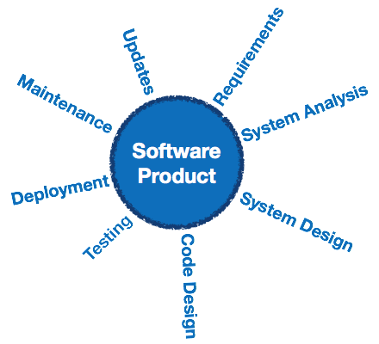
Software Evolution
The process of developing a software product using software engineering principles and methods is referred to as software evolution. This includes the initial development of software and its maintenance and updates, till desired software product is developed, which satisfies the expected requirements.
Software Evolution
Evolution starts from the requirement gathering process. After which developers create a prototype of the intended software and show it to the users to get their feedback at the early stage of software product development. The users suggest changes, on which several consecutive updates and maintenance keep on changing too. This process changes to the original software, till the desired software is accomplished.
Even after the user has desired software in hand, the advancing technology and the changing requirements force the software product to change accordingly. Re-creating software from scratch and to go one-on-one with requirement is not feasible. The only feasible and economical solution is to update the existing software so that it matches the latest requirements.
Need of Software Engineering
The need of software engineering arises because of higher rate of change in user requirements and environment on which the software is working.
Large software - It is easier to build a wall than to a house or building, likewise, as the size of software become large engineering has to step to give it a scientific process.
Scalability- If the software process were not based on scientific and engineering concepts, it would be easier to re-create new software than to scale an existing one.
Cost- As hardware industry has shown its skills and huge manufacturing has lower down he price of computer and electronic hardware. But the cost of software remains high if proper process is not adapted.
Dynamic Nature- The always growing and adapting nature of software hugely depends upon the environment in which user works. If the nature of software is always changing, new enhancements need to be done in the existing one. This is where software engineering plays a good role.
Quality Management- Better process of software development provides better and quality software product.
Characteristics of good software
A software product can be judged by what it offers and how well it can be used. This software must satisfy on the following grounds:
- Operational
- Transitional
- Maintenance
Well-engineered and crafted software is expected to have the following characteristics:
Operational
This tells us how well software works in operations. It can be measured on:
- Budget
- Usability
- Efficiency
- Correctness
- Functionality
- Dependability
- Security
- Safety
Transitional
This aspect is important when the software is moved from one platform to another:
- Portability
- Interoperability
- Reusability
- Adaptability
Maintenance
This aspect briefs about how well a software has the capabilities to maintain itself in the ever-changing environment:
- Modularity
- Maintainability
- Flexibility
- Scalability
In short, Software engineering is a branch of computer science, which uses well-defined engineering concepts required to produce efficient, durable, scalable, in-budget and on-time software products.
Software Development Life Cycle (SDLC) is a process used by the software industry to design, develop and test high quality softwares. The SDLC aims to produce a high-quality software that meets or exceeds customer expectations, reaches completion within times and cost estimates.
- SDLC is the acronym of Software Development Life Cycle.
- It is also called as Software Development Process.
- SDLC is a framework defining tasks performed at each step in the software development process.
- ISO/IEC 12207 is an international standard for software life-cycle processes. It aims to be the standard that defines all the tasks required for developing and maintaining software.

What is SDLC?
- SDLC is a process followed for a software project, within a software organization. It consists of a detailed plan describing how to develop, maintain, replace and alter or enhance specific software. The life cycle defines a methodology for improving the quality of software and the overall development process.
- The following figure is a graphical representation of the various stages of a typical SDLC.
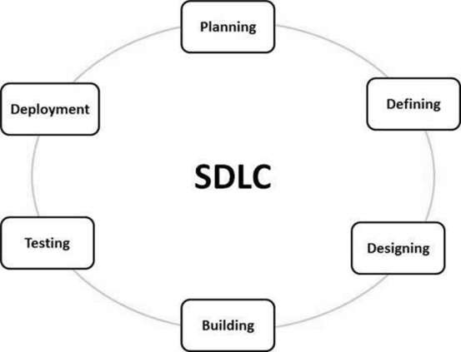
A typical Software Development Life Cycle consists of the following stages −

Stage 1: Planning and Requirement Analysis
Requirement analysis is the most important and fundamental stage in SDLC. It is performed by the senior members of the team with inputs from the customer, the sales department, market surveys and domain experts in the industry. This information is then used to plan the basic project approach and to conduct product feasibility study in the economical, operational and technical areas.
Planning for the quality assurance requirements and identification of the risks associated with the project is also done in the planning stage. The outcome of the technical feasibility study is to define the various technical approaches that can be followed to implement the project successfully with minimum risks.

Stage 2: Defining Requirements
Once the requirement analysis is done the next step is to clearly define and document the product requirements and get them approved from the customer or the market analysts. This is done through an SRS (Software Requirement Specification) document which consists of all the product requirements to be designed and developed during the project life cycle.

Stage 3: Designing the Product Architecture
SRS is the reference for product architects to come out with the best architecture for the product to be developed. Based on the requirements specified in SRS, usually more than one design approach for the product architecture is proposed and documented in a DDS - Design Document Specification.
This DDS is reviewed by all the important stakeholders and based on various parameters as risk assessment, product robustness, design modularity, budget and time constraints, the best design approach is selected for the product.
A design approach clearly defines all the architectural modules of the product along with its communication and data flow representation with the external and third party modules (if any). The internal design of all the modules of the proposed architecture should be clearly defined with the minutest of the details in DDS.

Stage 4: Building or Developing the Product
In this stage of SDLC the actual development starts and the product is built. The programming code is generated as per DDS during this stage. If the design is performed in a detailed and organized manner, code generation can be accomplished without much hassle.
Developers must follow the coding guidelines defined by their organization and programming tools like compilers, interpreters, debuggers, etc. are used to generate the code. Different high level programming languages such as C, C++, Pascal, Java and PHP are used for coding. The programming language is chosen with respect to the type of software being developed.

Stage 5: Testing the Product
This stage is usually a subset of all the stages as in the modern SDLC models, the testing activities are mostly involved in all the stages of SDLC. However, this stage refers to the testing only stage of the product where product defects are reported, tracked, fixed and retested, until the product reaches the quality standards defined in the SRS.

Stage 6: Deployment in the Market and Maintenance
Once the product is tested and ready to be deployed it is released formally in the appropriate market. Sometimes product deployment happens in stages as per the business strategy of that organization. The product may first be released in a limited segment and tested in the real business environment (UAT- User acceptance testing).
Then based on the feedback, the product may be released as it is or with suggested enhancements in the targeting market segment. After the product is released in the market, its maintenance is done for the existing customer base.
SDLC Models
There are various software development life cycle models defined and designed which are followed during the software development process. These models are also referred as Software Development Process Models". Each process model follows a Series of steps unique to its type to ensure success in the process of software development.
Following are the most important and popular SDLC models followed in the industry −
- Waterfall Model
- Iterative Model
- Spiral Model
- V-Model
- Big Bang Model
Other related methodologies are Agile Model, RAD Model, Rapid Application Development and Prototyping Models.
Waterfall Model
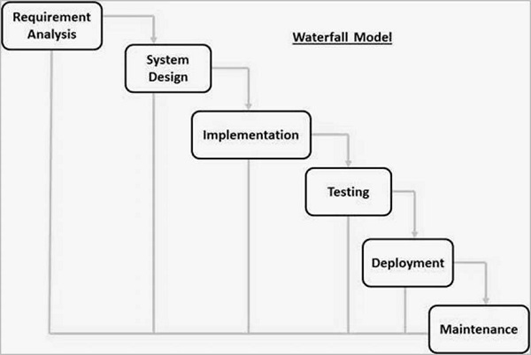
The Waterfall Model was the first Process Model to be introduced. It is also referred to as a linear-sequential life cycle model. It is very simple to understand and use. In a waterfall model, each phase must be completed before the next phase can begin and there is no overlapping in the phases.
The Waterfall model is the earliest SDLC approach that was used for software development.
The waterfall Model illustrates the software development process in a linear sequential flow. This means that any phase in the development process begins only if the previous phase is complete. In this waterfall model, the phases do not overlap.
Waterfall approach was first SDLC Model to be used widely in Software Engineering to ensure success of the project. In "The Waterfall" approach, the whole process of software development is divided into separate phases. In this Waterfall model, typically, the outcome of one phase acts as the input for the next phase sequentially.
The following illustration is a representation of the different phases of the Waterfall Model.
The sequential phases in Waterfall model are −

Requirement Gathering and analysis − All possible requirements of the system to be developed are captured in this phase and documented in a requirement specification document.

System Design − The requirement specifications from first phase are studied in this phase and the system design is prepared. This system design helps in specifying hardware and system requirements and helps in defining the overall system architecture.

Implementation − With inputs from the system design, the system is first developed in small programs called units, which are integrated in the next phase. Each unit is developed and tested for its functionality, which is referred to as Unit Testing.

Integration and Testing − All the units developed in the implementation phase are integrated into a system after testing of each unit. Post integration the entire system is tested for any faults and failures.

Deployment of system − Once the functional and non-functional testing is done; the product is deployed in the customer environment or released into the market.

Maintenance − There are some issues which come up in the client environment. To fix those issues, patches are released. Also to enhance the product some better versions are released. Maintenance is done to deliver these changes in the customer environment.

All these phases are cascaded to each other in which progress is seen as flowing steadily downwards (like a waterfall) through the phases. The next phase is started only after the defined set of goals are achieved for previous phase and it is signed off, so the name "Waterfall Model". In this model, phases do not overlap.
Waterfall Model - Application
Every software developed is different and requires a suitable SDLC approach to be followed based on the internal and external factors. Some situations where the use of Waterfall model is most appropriate are −

- Requirements are very well documented, clear and fixed.
- Product definition is stable.
- Technology is understood and is not dynamic.
- There are no ambiguous requirements.
- Ample resources with required expertise are available to support the product.
- The project is short.
Advantages
  - Before the next phase of development, each phase must be completed
  - Suited for smaller projects where requirements are well defined
  - They should perform quality assurance test (Verification and Validation) before completing each stage
  - Elaborate documentation is done at every phase of the software's development cycle
  - Project is completely dependent on project team with minimum client intervention
  - Any changes in software is made during the process of the development
  - Simple and easy to understand and use
  - Easy to manage due to the rigidity of the model. Each phase has specific deliverables and a review process.
  - Phases are processed and completed one at a time.
  - Works well for smaller projects where requirements are very well understood.
  - Clearly defined stages.
  - Well understood milestones.
  - Easy to arrange tasks.
  - Process and results are well documented.
Disadvantages
  - It does not allow much reflection or revision.
  - Once an application is in the testing stage, it is very difficult to go back and change something that was not well-documented or thought upon in the concept stage.
  - Error can be fixed only during the phase
  - It is not desirable for complex project where requirement changes frequently
  - Testing period comes quite late in the developmental process
  - Documentation occupies a lot of time of developers and testers
  - Clients valuable feedback cannot be included with ongoing development phase
  - Small changes or errors that arise in the completed software may cause a lot of problems
  - No working software is produced until late during the life cycle.
  - High amounts of risk and uncertainty.
  - Not a good model for complex and object-oriented projects.
  - Poor model for long and ongoing projects.
  - Not suitable for the projects where requirements are at a moderate to high risk of changing. So, risk and uncertainty is high with this process model.
  - It is difficult to measure progress within stages.
  - Cannot accommodate changing requirements.
  - Adjusting scope during the life cycle can end a project.
  - Integration is done as a "big-bang. at the very end, which doesn't allow identifying any technological or business bottleneck or challenges early.
Prototyping Model
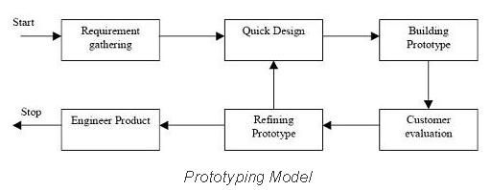
  - Instead of freezing the requirements before a design or coding can proceed, a throwaway prototype is built to understand the requirements.
  - This prototype is developed based on the currently known requirements.
  - By using this prototype, the client can get an “actual feel” of the system, since the interactions with prototype can enable the client to better understand the requirements of the desired system.
  - Prototyping is an attractive idea for complicated and large systems for which there is no manual process or existing system to help determining the requirements.
  - The prototype are usually not complete systems and many of the details are not built in the prototype.
The goal is to provide a system with overall functionality
Advantages
  - Users are actively involved in the development.
  - Since in this methodology a working model of the system is provided, the users get a better understanding of the system being developed.
  - Errors can be detected much earlier.
  - Quicker user feedback is available leading to better solutions.
  - Missing functionality can be identified easily
  - Confusing or difficult functions can be identified
Requirements validation, Quick implementation of, incomplete, but
functional, application.
Disadvantages
  - Leads to implementing and then repairing way of building systems.
  - Practically, this methodology may increase the complexity of the system as scope of the system may expand beyond original plans.
  - Incomplete application may cause application not to be used as the full system was designed.
  - Incomplete or inadequate problem analysis.
When to use Prototype model:
  - Prototype model should be used when the desired system needs to have a lot of interaction with the end users.
  - Typically, online systems, web interfaces have a very high amount of interaction with end users, are best suited for Prototype model.
  - It might take a while for a system to be built that allows ease of use and needs minimal training for the end user.
  - Prototyping ensures that the end users constantly work with the system and provide a feedback which is incorporated in the prototype to result in a useable system.
  - They are excellent for designing good human computer interface systems.
Spiral Model
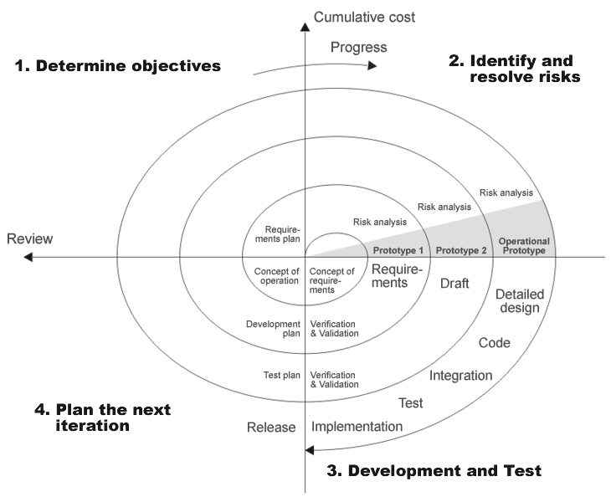
  - The spiral model is similar to the incremental model, with more emphasis placed on risk analysis.
  - The spiral model has four phases: Planning, Risk Analysis, Engineering and Evaluation.
  - A software project repeatedly passes through these phases in iterations (called Spirals in this model).
  - The baseline spiral, starting in the planning phase, requirements are gathered and risk is assessed.
  - Each subsequent spirals builds on the baseline spiral.
Planning Phase:
    - Requirements are gathered during the planning phase.
    - Requirements like ‘BRS’ that is ‘Business Requirement Specifications’ and ‘SRS’ that is ‘System Requirement specifications’.
Risk Analysis:
    - In the risk analysis phase, a process is undertaken to identify risk and alternate solutions.
    - A prototype is produced at the end of the risk analysis phase.
    - If any risk is found during the risk analysis then alternate solutions are suggested and implemented.
Engineering Phase:
    - In this phase software is developed, along with testing at the end of the phase.
    - Hence in this phase the development and testing is done.
Evaluation phase:
    - This phase allows the customer to evaluate the output of the project to date before the project continues to the next spiral.
Advantages of Spiral Model
  - High amount of risk analysis hence, avoidance of Risk is enhanced.
  - Good for large and mission-critical projects.
  - Strong approval and documentation control.
  - Additional Functionality can be added at a later date.
  - Software is produced early in the software life cycle.
Disadvantages of Spiral Model
  - Disadvantages Can be a costly model to use.
  - Risk analysis requires highly specific expertise.
  - Project’s success is highly dependent on the risk analysis phase.
  - Doesn’t work well for smaller projects.
When to use Spiral model
  - When costs and risk evaluation is important
  - For medium to high-risk projects
  - Long-term project commitment unwise because of potential changes to economic priorities
  - Users are unsure of their needs
  - Requirements are complex
  - New product line
  - Significant changes are expected (research and exploration)
Rapid Application Development (RAD) Model
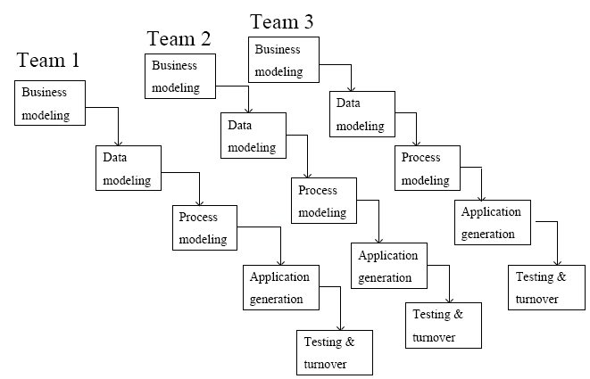
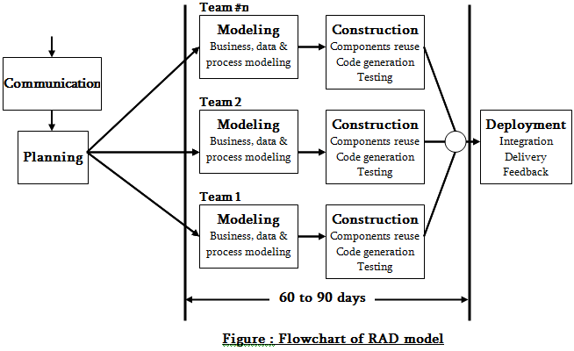
Introduction
  - RAD - Rapid application development.
  - It is adoption of waterfall model, It aims at developing a software in a short span of time.
  - It accept sufficient time for study of existing system
  - Accept sufficient number of staff for development
  - Staff is distributed in various team
  - It concentrates on input output source and destination of information.
  - It is based on Model Phases.
  - Communication : Understand business problem as well as it tries to identify all types of problems and gather all types of information
  - Planning: It divides work into manageable different parts and distribute among the various team.
  - Modelling: It will be accomplished by the different teams simultaneously.
It include phases
  - Construction: Each team develop the code of product as well as perform testing.
  - Uses reuse old software components & develops new functions
  - Deployment: Collect Code of each team & club them into single project Implement & if required iterate previous phases
Model Phases
  - Business modeling
  - Data modeling
  - Process modeling
  - Application generation
  - Testing and turnover
Business Modeling:
  - The information flow among business functions is defined by answering questions like what information drives the business process, what information is generated, who generates it, where does the information go, who process it and so on.
Data Modeling
  - The information collected from business modeling is refined into a set of data objects (entities) that are needed to support the business.
  - Shows the flow of data using some techniques like DFD
  - The attributes (character of each entity) are identified and the relation between these data objects (entities) is defined.
Process Modeling
  - The data object defined in the data modeling phase are transformed to achieve the information flow necessary to implement a business function.
  - Processing descriptions are created for adding, modifying, deleting or retrieving a data object.
Application Generation
  - Automated tools are used to facilitate construction of the software;
  - Even they use the 4th GL techniques.
  - The term fourth-generation programming language (abbreviated 4GL) is better understood to be a fourth generation environment; packages of systems development software including very high level programming languages.

Testing and Turnover
  - Many of the programming components have already been tested since RAD emphasis reuse.
  - This reduces overall testing time.
  - But new components must be tested and all interfaces must be fully exercised.
Advantages
  - Quick initial reviews are possible.
  - Constant integration isolate problems and encourage customer feedback.
  - Flexible and adaptable to changes.
  - RAD realizes an overall reduction in project risk.
  - RAD generally incorporates short development cycles - users see the RAD product quickly.
Disadvantage
  - Requires a systematic approach for modularized.
  - Requires highly skilled and well-trained developers`.
  - It doesn’t work in high technical risk
  - If high performance is the issue rad does not work
  - Product may lose its competitive edge because of insufficient core functionality and may exhibit poor overall quality.
Conclusion
  - Requires minimal planning in favor of rapid prototyping.
  - Instead of using codes, developers use different tools and software development kits and bring them all together to create a software.
  - Developers who are time challenged could use this application development.
Rational Unified Process
The Rational Unified Process (RUP) is a software development and project management process that provides a disciplined and methodical approach towards assigning tasks and responsibilities in a team.
Developed by Rational Software, it is used to build complex systems and covers the entire software development life cycle (SDLC).
RUP can be applied to project types ranging from small applications to large-scale, complex systems.
The goal of RUP is to help organizations meet the challenges of developing software products for today’s changing business environments.
RUP is a systematic way to allocate tasks and responsibilities within a development team that offers best practices and guidelines for effective software development.
By doing so, it is able to produce high-quality software on time and within budget while satisfying the demands of its customers.
There are four main phases in RUP: Inception, Elaboration, Construction, and Transition.
Each phase has its own objectives, activities, and deliverables.
The key principles of RUP include:
- Iterative and incremental development: RUP emphasizes iterations, or cycles, of work, rather than trying to complete all work upfront.
- This allows for more flexibility and responsiveness to change.
- Each iteration results in a working version of the software that can be demonstrated to, and used by, clients.
Strong focus on requirements: RUP puts strong emphasis on requirements gathering and management.
- A project’s success depends on having a clear understanding of what the client wants the final product to do.
- Only then can developers and project managers plan out the necessary steps to create it.
Architecture-centric development:
- RUP takes an architecture-centric approach, meaning that the software’s overall design is created first before any code is written.
- This ensures that the final product will be well-structured and maintainable.

Component-based development:
Component-based development is a technique for building software systems from pre-existing components rather than from scratch.
This speeds up development time and results in more reliable code since proven components are reused.
Phases of the Rational Unified Process
Inception
During the Inception phase, the main objectives are to acquire stakeholder agreement on the project’s goals and to secure funding.
This will require creating a high-level requirements model, which will define the project’s scope, and possibly developing a user interface prototype.
You are responsible for initiating the work environment installation and processing customization for the team. Moreover, you will develop a high-level plan for the project’s progress.
It would help if you defined the business case and the project’s scope during the inception phase.
Note that a business case includes success criteria, a risk assessment, a resource estimate, and a milestone phase plan.
You should identify all external entities with whom the system will interact (actors) and specify the nature of the interactions at a high level.
You should also conduct a risk analysis to determine any potential risks that may be detrimental to the success of your project.
Elaboration
This is the most crucial of all the four stages of RUP, in which you examine the project’s requirements and necessary architecture, review the challenges, design the project plan and architect, and remove the high-risk aspects from the project.
The system requirements and architecture are evaluated and analyzed during the elaboration phase.
The elaboration phase involves analyzing products and laying the groundwork for future architecture.
During this phase, the project team gains a comprehensive understanding of the system. The requirements are elaborated and refined in this phase, and a preliminary design is created.
The objective of the elaboration phase is to produce a comprehensive and accurate description of the system to be built.
Construction
The complete software system is developed during the Rational Unified Process building phase.
The focus is on the creation of system components and other features. Additionally, the bulk of coding occurs at this time.
The construction phase of the Rational Unified Process is the longest and most complex.
This phase takes place over a period of six months, with each month divided into two two-week iterations.
In this process, the focus is on cost and resource management and quality assurance.
The application is built and tested in the construction stage of RUP.
This includes creating components, testing those components, and then assembling the pieces into a working system.
During construction, developers create software components and test them to ensure they meet the requirements specified in earlier phases. To do this effectively, developers need to
understand the system’s architecture and design clearly.
Transition
This is the final step in the entire product development life cycle that entails a transition from the development to the production stage.
In the transition phase, testing is conducted on the software, defects are removed, and the software is released.
The software is published and distributed to customers or end-users during this phase.
The product will be updated or altered based on input from end users.
During the transition phase, a software product is introduced to the user community so that they can become familiar with its capabilities.
When the product has been delivered to the end user, there might be defects, requirements for updated versions, etc.
Roles of System Analyst
  - Defining and Prioritizing Requirements
  - Gathering Data, Facts and Opinions of Users
  - Analysis of Requirements
  - Drawing Requirements Specifications
  - Designing Solution System.
  - Evaluating Systems
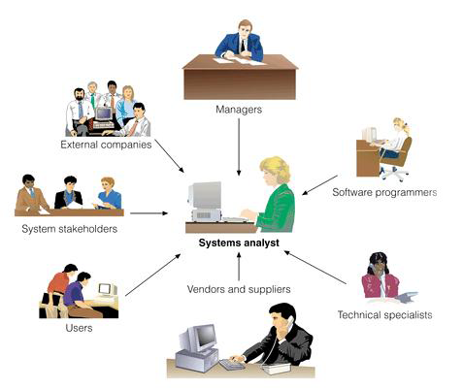
Skills of System Analyst
  - Good Interpersonal Skills
  - Good Communication Skills
  - Problem solving ability
  - Updated Knowledge of Latest Computer Technologies
  - Knowledge of Business objective
  - Ability to guide people through period of change
  - Domain Knowledge of software system
  - Analytical Skills
ROLES & RESPONSIBILITIES OF SYSTEM ANALYST
  - Each company needs to define the specific roles and responsibilities that an analyst plays in their organization. However, the general roles and responsibilities of an analyst are defined below.
  - The role of an analyst is to help organizations understand the challenges before them to make this transition and to ensure that the needs and expectations of the client are represented correctly in the final solution.
  - In general, the analyst is responsible for ensuring that the requirements set forth by the business are captured and documented correctly before the solution is developed and implemented.
  - In some companies, this person might be called a Business Analyst, Business Systems Analyst, Systems Analyst or a Requirements Analyst.
  - While each of these titles has their particular nuances, the main responsibility of each is the same - to capture and document the requirements needed to implement a solution to meet the clients' business needs.
  - if requirements are not captured and documented, the analyst is accountable.
  - if the solution meets the documented requirements, but the solution still does not adequately represent the requirements of the client, the analyst is accountable.
Process Responsibilities
  - Once the Analysis Phase begins, the analyst plays a key role in making sure that the overall project successfully meets the client needs. This includes:
  - Analyzing and understanding the current state processes to ensure that the context and implications of change are understood by the clients and the project team
  - Developing an understanding of how present and future business needs will impact the solution
  - Identifying the sources of requirements and understanding how roles help determine the relative validity of requirements
  - Developing a Requirements Management Plan and disseminating the Plan to all stakeholders
  - Identifying and documenting all business, technical, product and process requirements
  - Working with the client to prioritize and rationalize the requirements
  - Helping to define acceptance criteria for completion of the solution
  - Again, this does not mean that the analyst physically does all of this work. There may be other people on the team that contribute, including the project manager. However, if the finished solution is missing features, or if the solution does not resolve the business need, then the analyst is the person held accountable.
Analyst Skills
  - Generally, analysts must have a good set of people skills, business skills, technical skills and soft skills to be successful. These include:
  - Having good verbal and written communication skills, including active listening skills.
  - Being well organized and knowing good processes to complete the work needed for the project.
  - Building effective relationships with clients to develop joint vision for the project.
  - Assisting the project manager by managing client expectations through careful and proactive communications regarding requirements and changes.
  - Negotiating skills to build a final consensus on a common set of requirements from all clients and stakeholders.
  - Ensuring that stakeholders know the implications of their decisions, and providing options and alternatives when necessary.

